**SECTION 4.1:** Industry Analysis

DESCRIPTION:

Our industry analysis is comprised of financial data taken from Industry Canada’s website from two separate industries due to the nature of our facility mixing fitness and video game technologies.

INDUSTRY CANADA - FITNESS AND RECREATIONAL SPORTS CENTRES (NAICS 71394): FINANCIAL PERFORMANCE DATA

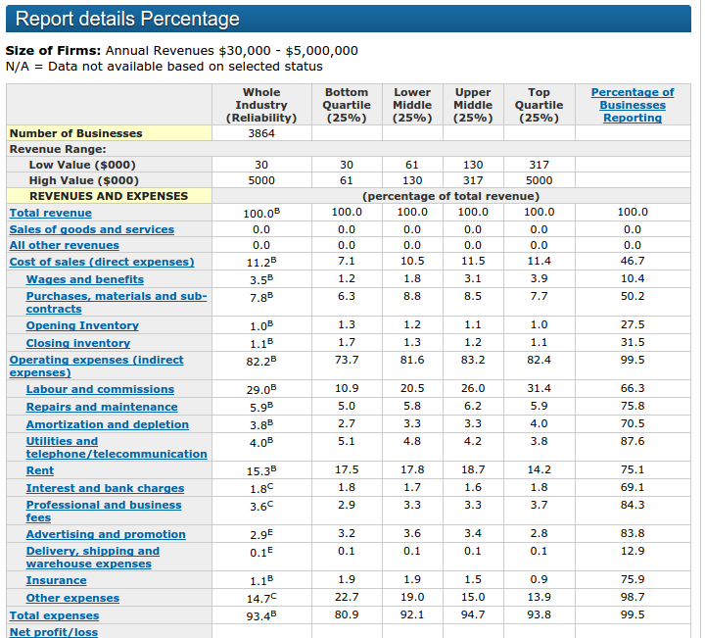

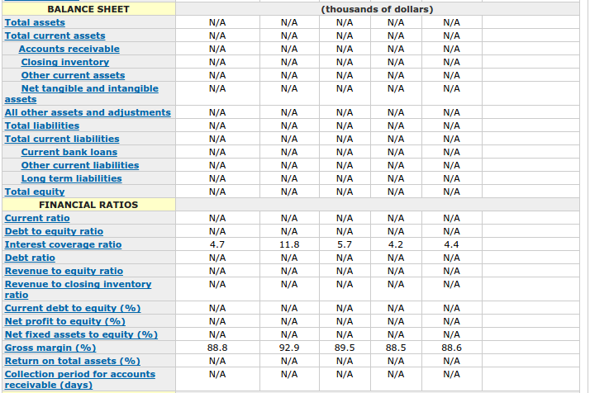

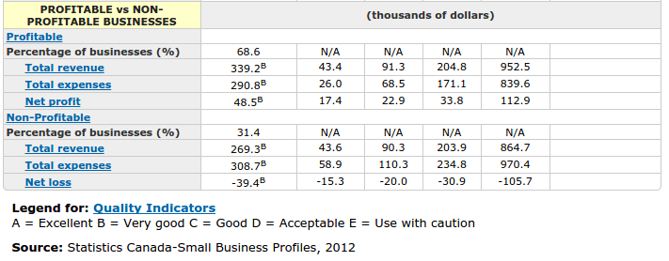

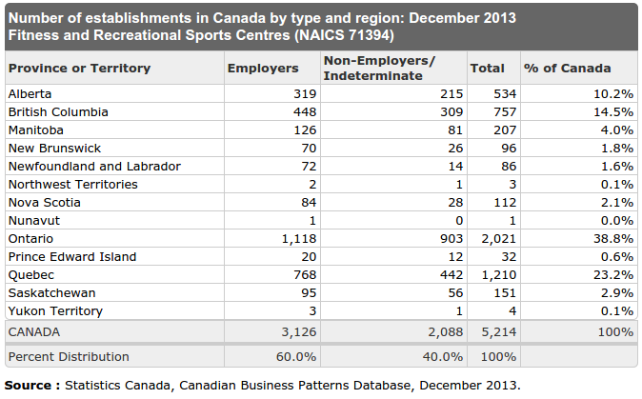

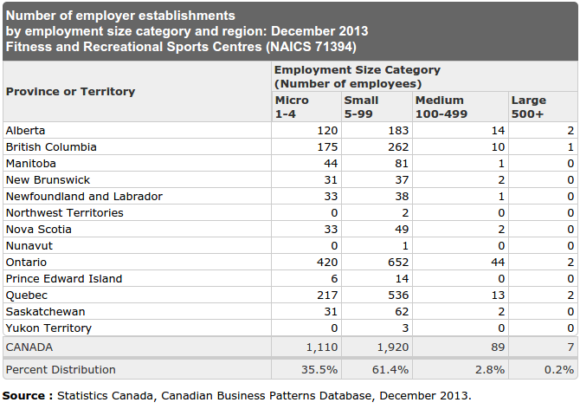

INDUSTRY CANADA - AMUSEMENT ARCADES (NAICS 71312): FINANCIAL PERFORMANCE DATA

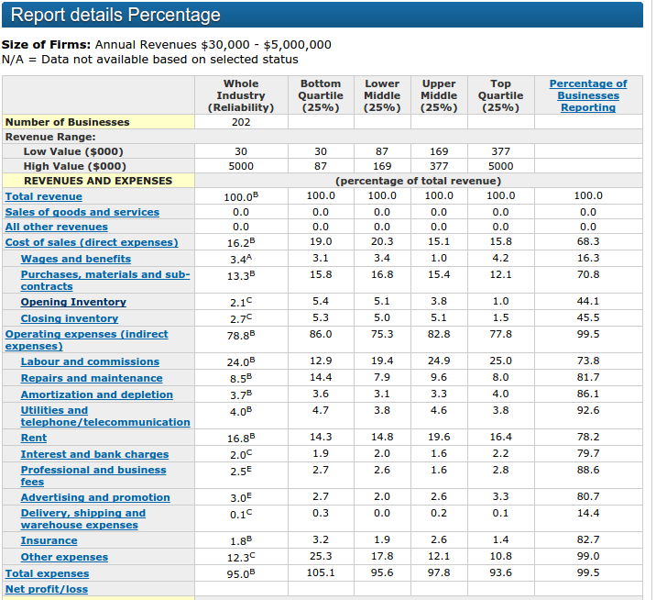

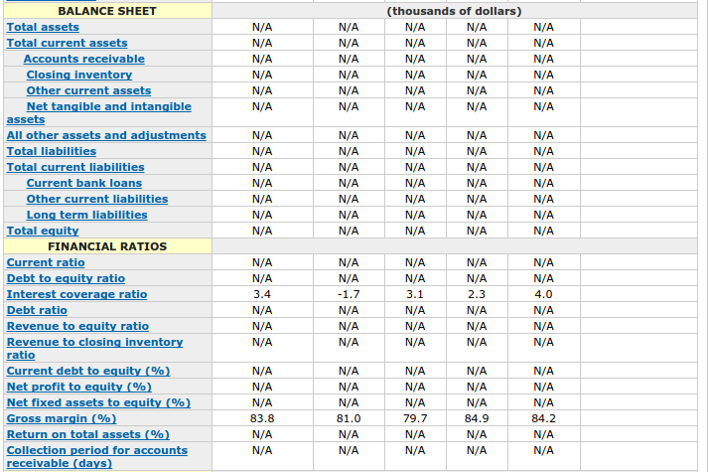

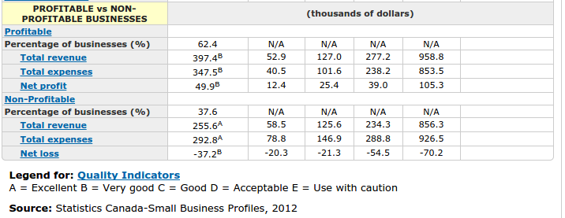

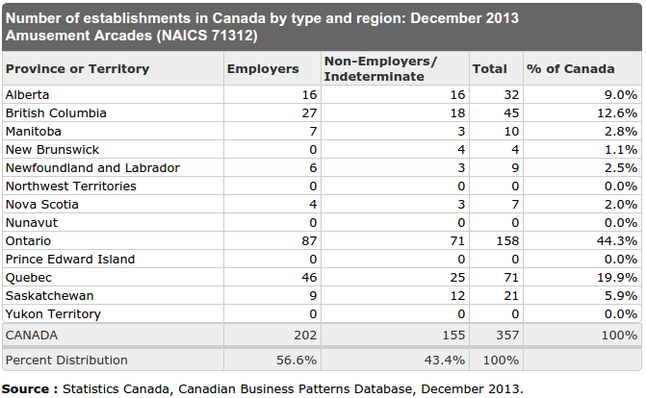

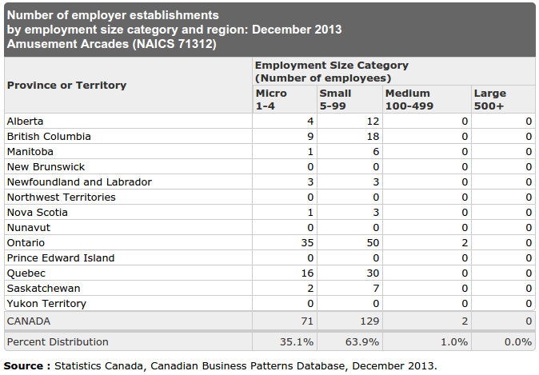

**SECTION 4.1.1:** Market Size

DESCRIPTION:

Based on the prior reports shown for both industries we define the market size based on the data researched and estimates due to our industry being a unique niche market.

PEI BASED

|  |  |
| --- | --- |
| EXERGAMING FITNESS FACILITIES | 0 |
| FITNESS AND RECREATIONAL SPORTS CENTRES | 32 |
| AMUSEMENT ARCADES | 0 |

Through our research of known fitness facilities located here in Prince Edward Island we have found they contain no known exergaming equipment. Therefore our market size is estimated to be 100%. The YMCA was found to be the largest purchaser of exergaming equipment, but the facility located locally has no such equipment.

**SECTION 4.1.2:** Main Competitors

DESCRIPTION:

We define three main competitors and include a brief summary about each one. Our summary includes the competitors methods to market their offerings, their size, number of locations, website address and additional information that we believe was relevant

* THE SPA

|  |  |
| --- | --- |
| Size: | 10,000sqft |
| Number of locations: | 1 |
| Website address: | http://spatotalfitness.com/ |
| Methods to market: | Offered as a service |
| Additional information: | * Swimming Pool * Racquetball Courts * Tennis Courts * Indoor track |

* ATLANTIC FITNESS CENTER

|  |  |
| --- | --- |
| Size: | 6000 sqft |
| Number of locations: | 2 |
| Website address: | http://www.atlanticfitness.ca/ |
| Methods to market: | Offered as a service |
| Additional information: | * Yoga classes free to members * Some locations have tanning beds * TRX Suspension Training * Various types of classes |

* CORNWALL APM CENTER

|  |  |
| --- | --- |
| Size: | 1200 square feet fitness room + gymnasium |
| Number of locations: | 1 |
| Website address: | http://www.apmcentre.com/ |
| Method for offerings | Offered as a service |
| Additional information: | * Contains a rink * Has a canteen located within the building * Facility is wheelchair accessible * Various programs offered |

**SECTION 4.1.4**: Market Segments

DESCRIPTION:

Within this section we review our segments (targets) and analyze each

by breaking down each segment into these categories:

Demographic, Psychographic, and Behavioural ???

**SECTION 5.4:** Competitive Edge

DESCRIPTION:

Below is a description of how we will compete with our market competition and rise above the bar that is currently set.

The largest difference between us and regular gyms is our comprehensive experience tracker database which allows our members to view, in real-time, all of the progress they are making. Our core values revolve around motivating our members to want to exercise through motivation and fun.

A large portion of people who purchase gym memberships end up quitting or rarely go. We believe that this is because they have no way of viewing their progress, and the physical progress is much too slow to view and believe it is worth it. With our skill tracker database, it not only makes exercise feel like a fun game, it allows you to see all the progress you actually have made.

The main reason why video games are so addicting is the urge to better your character in some way. The user can view their characters skills, experience, items and more from inside the game. This is what we aim for with our skill tracker, and hope to give that same urge to better yourself in the real world.

Our prices fit directly around our competition of regular gyms, but we also offer large discounts for long-term membership purchases. We also offer day passes for visitors to get a feel for how our facility works. Our main goal is to promote healthy living and do not aim for a large profit. This allows us to put much of the gained funds back into the system and improve it for our members.

We offer ways to view your experience, stats and more online through our website. Through the use of our website you can do much more such as, interact with other members, share stories about your fitness goals and even motivate others who are having a hard time.

**SECTION 5.5:** Marketing Strategy and Positioning

DESCRIPTION:

With each of our market segments, we describe below our positioning to market towards them.

**Pricing Strategy**

Our pricing strategy is competition-based pricing. We chose this method because gym environments typically have around the same price, depending on their size and amount of equipment. Our equipment costs are relatively high, and other costs such as electricity are high because of the equipment. The current prices allow us to pay these off and are similar to the larger gyms available in the area.

**Promotion and Advertising Strategy**

Word of Mouth:

Word of mouth will be our primary means of promotion and advertising. The reason this is so important is because our facility caters to a niche group and many in this group want to better themselves through exercise but simply do not have the motivation to do so.

People, for the most part, associate themselves with like-minded people. We believe once our members begin viewing how good this system is they will communicate with their friends.

Our facility is also only a local business for the time being and makes it much less cost-effective to do any large advertising outside of the immediate region.

Social Media:

We will run groups on social media websites such as, Twitter, and Facebook. Through these we will communicate any sales, events and more to our members and others who are thinking of joining.

Being a free means of advertising and how widely it is used we think this is an excellent way to draw in new members. Our targeted members are generally very tech oriented and use social media websites often for various means.

Forums:

Our website will have discussion forums where users can share their fitness stories, talk to other members and motivate others to join or continue through to their goals.

We will have a special area of the forum where users can input their goals and track the date of their desired finish. We will push these posts to the top so that other users can view and discuss with that user how their goals went, if they succeeded and so forth. It is much harder to not finish a goal when you tell others that you have that goal, because you don’t want to disappoint them or yourself.

We will allow anyone to create an account for our website and thus use our forums, so anyone unsure about joining can talk to others and hopefully decide to give it a shot.

**Marketing Programs:**

Word of Mouth:

Budget - $0

Manager - N/A

Time-Table - Duration of business

Goals:

* Members will discuss the idea of fitness and healthy living with their friends
* They will also discuss how it can be fun!
* Bring in their friends for a trial with our day passes and acquire new members
* Bring in ~10 members per month

Social Media:

Budget - $0

Manager - Gaylene Nicholson

Time-Table - Duration of business

Goals:

* Share our goals, events and promotions with our members and prospective members
* Have an active face in the fitness community
* Bring in ~6 members per month

Forums:

Budget - (website-hosting costs)

Manager - Michael Gergely

Time-Table - Duration of business

Goals:

* Have an active area to talk with other members, share goals and more
* Area for prospective members to talk with staff or other members
* Bring in ~5 members per month

**SECTION 5.2:** Strategy Pyramids

DESCRIPTION:

Our strategic goals are broken down into pyramid views so that we can see the steps necessary to achieve our end result. We limit the number of goals we chose so that focus remains strong on each strategy.

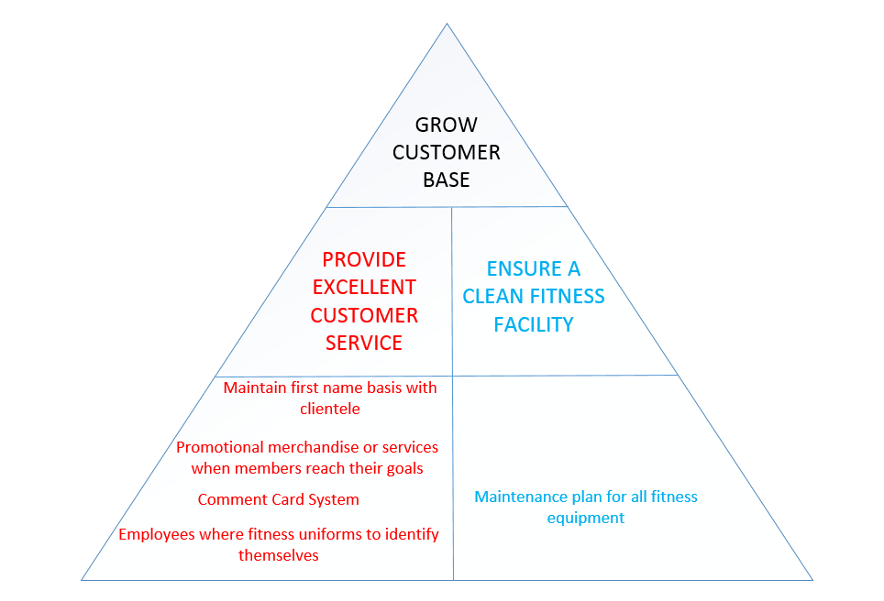

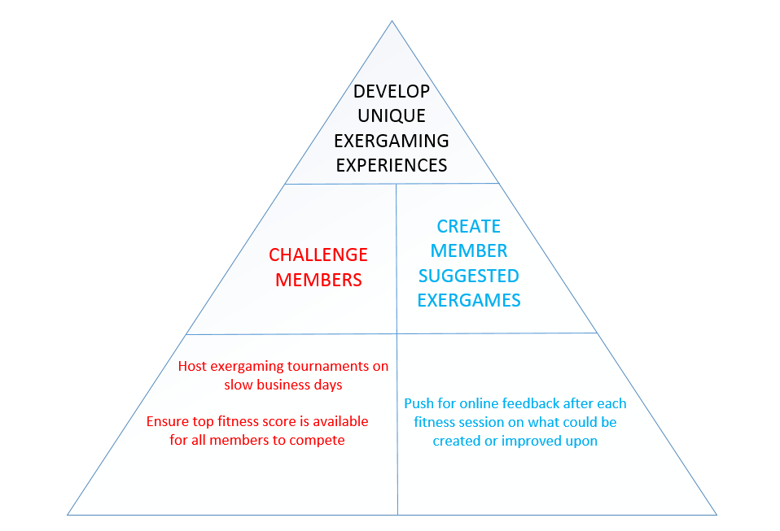

**SECTION 5.7:** Legal

DESCRIPTION:

Here we describe our legal issues such as fitness insurance, software patents and copyright regulations.

FITNESS / HEALTH CLUB INSURANCE

In order for our facility to be fully insured and cover any liabilities that may incur, we would be required to hold a specific fitness facility insurance policy that would protect not only the business, equipment and facility, but its members as well.

Sports & Fitness Insurance Canada

http://www.sportsfitnesscanada.com/wp/wp-content/uploads/2012/07/EGuide-Health-Clubs.pdf

Commercial General Liability (CGL):

Example Scenario:

Member trips over machine and brakes elbow

Professional Liability (E&O):

Example Scenario:

Member was injured by equipment due to lack of maintenance.

Property:

Example Scenario:

Sump pump malfunctions and causes water damage throughout the gym

Crime:

Example Scenario:

Employee is found pocketing fees when signing up members

EXERGAMING & PROFILE SYSTEM SOFTWARE

We are considered an independent software development team creating exergaming software designed to run on the Xbox One and Wii-U gaming consoles.

XBOX SOFTWARE DEVELOPMENT

URL: http://www.xbox.com/en-CA/Developers/id

* + Developer application form required
  + Access to two development kits at no cost
  + Access to all required technical documentation
  + No fees to update any game submitted through the program.
  + Games released through the program also have access to all Xbox One and Xbox Live components, including Kinect, Achievements and Xbox SmartGlass
  + Access to the Unity engine as well as an optional subscription to Unreal Engine 4.
  + Certify with no fees and get access to go-to-market playbook.

WII-U SOFTWARE DEVELOPMENT

URL: https://wiiu-developers.nintendo.com/

* + Developer Application form required to become a Wii U developer.
  + Free development tools ( Unity paid license through Nintendo or NWF )
  + Game Development
  + On-going support
  + Free of charge to participate in the program and to submit games to Nintendo for technical certification
  + Cost involved for Wii U development hardware

GYM PROFILE SOFTWARE

As a software development team designing software to be used in a commercial environment we would be required to register our creation with the Canadian Intellectual Property Office (CIPO). Our business name and product has the following currently registered:

TRADE NAME & TRADEMARK:

Level Up! Gym ( 15 year registration timeline )

COPYRIGHT:

Gym Profile Software ( Lifetime registration )

PATENT:

Gym Profile Software ( 20 year registration timeline )

**SECTION 5.7:** Milestones

DESCRIPTION:

We list and define each of our milestones here. This is to ensure that we keep our business on track and that we can measure the successfulness of our business

|  |  |
| --- | --- |
| **MILESTONE** | **TARGET DATE** |
| Reach 50 customers membership mark | 1 month after business is opened |
| Reach 500 customer membership mark | 2 years after business is opened |
| Recognition as most innovative fitness facility | 5 years after business is opened |
| Purchase additional large scale exergaming fitness units  ( similar to the Eye Play Interactive Floor ) | 6 years after business is opened |
| Establish health food venue within the facility | 6 years after business is opened |
|  |  |

**SECTION 5.7:** Exit Strategy

DESCRIPTION:

Below we outline our business exit strategy in the event that our business fails to

produce an acceptable source of income or we have decided to move into a different market altogether

TRIGGERS

* + Unable to produce an acceptable income in order to support management team members.
  + Unanimous decision in favor of terminating the business

SELLING THE BUSINESS AS A WHOLE

If this choice is a viable one we would be willing to sell the business outright to a potential buyer.

The business would be sold as a whole with all inventory and assets outlined in the sale agreement including the following items:

* Trademark of Level Up! Gym
* Patent for profile software system
* Licenses for exergaming software
* Goodwill

|  |  |
| --- | --- |
| **CURRENT ASSETS** | **WORTH** |
| T-Shirt Merchandise | $15 per unit |
| Pepsi Products | Sold back to Pepsi |
| Mana Potion Products ( can vary depending on stock ) | $3 per unit |

|  |  |
| --- | --- |
| **FIXED ASSETS** | **WORTH** |
| Fitness Facility | Amount of paid-in equity |
| Polk Audio Bookshelf Speaker (R150) – Pair | $1,200.00 |
| Xbox Console Systems + Kinect | $2,000.00 |
| Wii-U Console Systems | $800.00 |
| NEC NP-VE281X Projectors | $6,000.00 |
| NEC NP-VE281X Projector Lamp Replacements | $1,000.00 |
| Eye Play Interactive Floor | $10,000.00 |
| Treadmill Fitness Machinery | $4000.00 |
| Elliptical Fitness Machinery | $4000.00 |
| Stationary Bicycles | $4000.00 |
| Samsung Gear VR | $6,000.00 |
| Mats, Dumbbells, Hula-hoops, Rubber Flooring, Lockers, Gym style benches | $2000.00 |
| Small Sofa's / Loveseats | $5,000.00 |
| Large Desk for Front Desk Area | $100.00 |
| Insignia - 200W 2.0-Ch. Stereo Receiver – Black | $800.00 |

|  |  |
| --- | --- |
| **INTANGILE ASSETS** | **WORTH** |
| Trademark: Level Up! Gym | $10,000 |
| Patents: Exergaming software | $100,000 |
| Patents: Profile Software System | $100,000 |

|  |  |
| --- | --- |
| **GOODWILL** | **$50,000** |

|  |  |
| --- | --- |
| **TOTAL WORTH FOR SELLING** | **$306,000 + Paid-in equity + Inventory** |